Main Org

Functionality: This screen is a user-friendly screen that allows the user to view details of the Main org. It also allows the user to edit all fields within the org, in an efficient manner. The Main Org contains several tabs: Summary Page, Insurance, Clearing House, Personnel and Catalog. There is also a profile line. Only priority 5 items will be discussed in this document. Others will be mentioned with a notation that details will come in a later document.

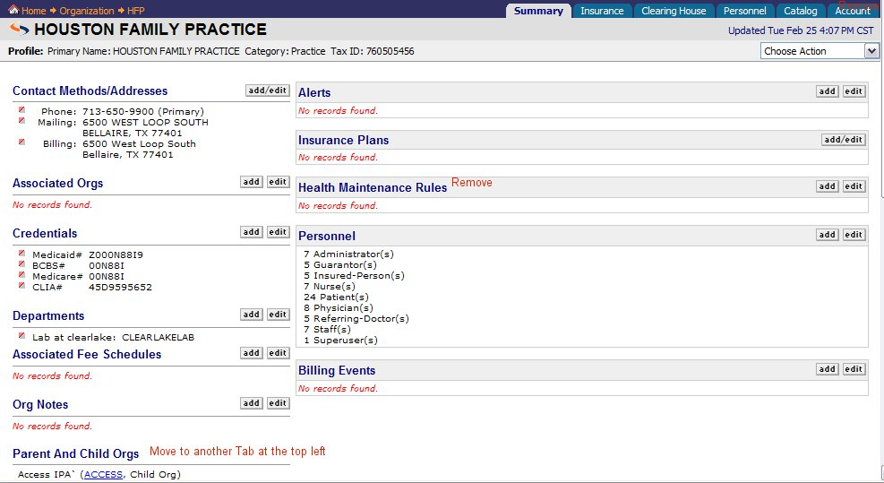

Profile

This is a priority 5. The profile line is originally created when the user enters information form the Add-Main Org Dialogue. It consists of Name of Org, Category and Tax ID. A user can edit it from the choose action button.
The choose action on this screen only needs the choice of “Edit Profile”→Application brings up dialogue containing existing information
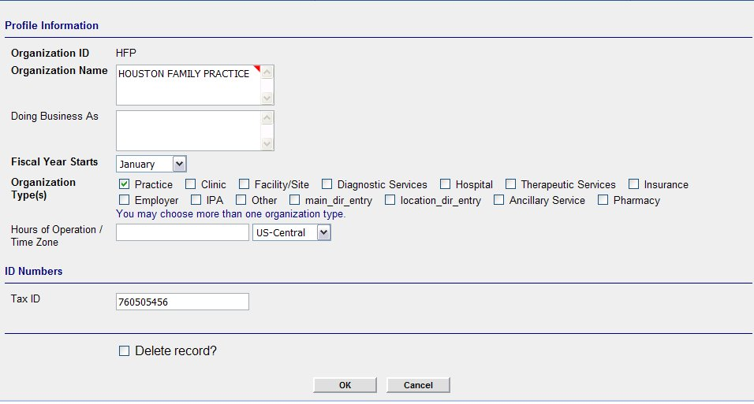
User changes any information, except the Org ID→User clicks [OK]→Application makes the appropriated changes and saves→Application takes user back to Summary Page.
***Delete button should be removed from Main Org. There should not be a user interface to delete a Main Org.***

Tabs
These tabs serve as files with information in them that are related to each other.

Summary Tab: Priority 5

This tab consists of basic information that is directly related to the Main Org. On this page the user should be able to view/add/edit the following Categories: Contact Methods/addresses, Credentials, Org Notes, and Alerts.

This tab is an overview of information entered in Add a Main Org dialogue. The users can add/edit information on this screen. The screen in Physia handles the majority of this but the following Categories should be removed:

Parent And Child Orgs: Removed
Insurance Plans: Removed
Health Maintenance Rules: Removed

Associated Orgs: Move to Associated Orgs Tab
Departments: Move to Associated Orgs Tab
Personnel: Move to Personnel Tab
Billing Events: Move to Account Tab

Category: Contact Methods/Addresses
This category includes all information needed to contact the Org.

Add/Edit Function

Functionality: The user has the ability to add or edit any entry from the summary page and other tabs within the Org. The add/edit function should function the same for each category on the summary page.

Add:
The user is able to add new information to a sub category by clicking the ADD/Edit button near the category. In Physia, it is a Hyperlink on the word Add/Edit. If the user does not see the information in the sub category and wishes to add it, then they click the hyperlink→application takes user to add/edit dialogue→
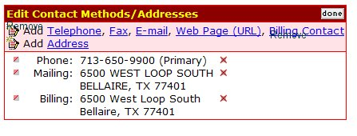
**Note: Remove the Add icons , because it is redundant. Remove billing contact because it is no longer used.

The user clicks the item to add. (In this example it is Telephone) →Application takes user to dialogue for add telephone→
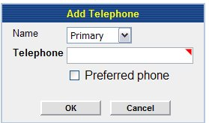

The user has the ability to choose which type of phone number they want to enter. This is in the form of a drop down box. 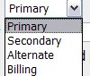. User enters required information (again marked with a required field indicator) →User clicks [OK]→application shows new information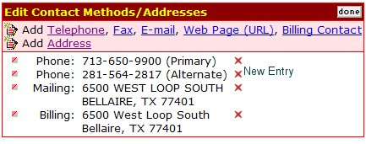

The user clicks [done]→ application takes user back to summary page.

If the user chooses to edit an existing item, at this point, they may choose the to the left of the item and the following dialogue on using the will begin.

Edit: The user can edit from a couple of ways. They can do the short cut and use the edit button in front of the existing item they wish to edit. (In Physia this is the .) Or the user can click the add/edit button on the category box. .

Takes the user directly to the edit dialogue for the item chosen. For example if the user chooses to edit the mailing address the following screen is displayed.
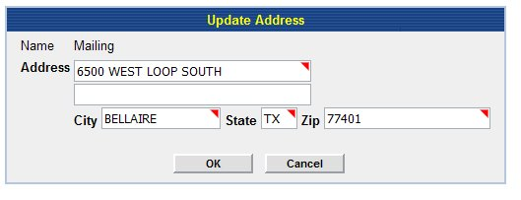
All the information is auto filled. The user simply uses the mouse to move the cursor to the correct box and enters the new information.→User clicks [OK]→application takes user to a screen that displays the edited information and a notification that update complete: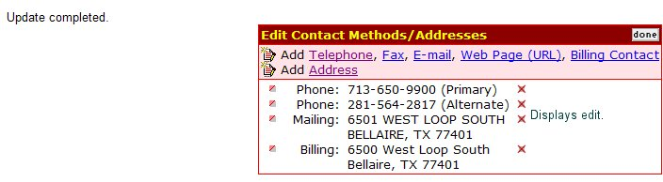

User clicks [done] →Application takes user back to Summary Page.
If user clicks in front of another entry→application takes user to edit dialogue for the chosen item→application continues loop until user clicks [done].

The application should follow the same line of actions for each item in a category. Any differences will be noted within the category below.

This is generally used for adding new items but the user is taken to the add/edit dialogue and has to click the icon in order to edit a field. Once they click the , the user is taken through the actions described above for the . This is a longer process but since the Add dialogue takes you to the same screen and a user can edit an existing item when there, it makes since to keep it. However, the user will be trained in the most efficient way to edit an item.

Category: Credentials
This category contains any certificates, group numbers or ID’s entered in the Add a Main Org Dialogue.

Add/edit functions the same as above for Contact Methods/Addresses.

****Note: in Physia, the edit feature for certificates does not work all the time. When application pulls up the item to be edited, 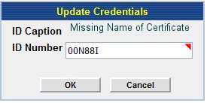

And when change is made, the Id Name is missing (see below).
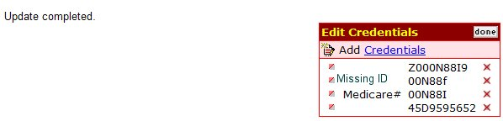
Once the user clicks done—the id is still missing from the Summary Page.



Category: Org Notes ***not a priority 5—will discuss details in a future document**
This field allows the user to free text any notes they wish to add to Org.

Category: Alerts***not a priority 5—will discuss details in a future document**
This field allows the user to enter free text alerts pertaining specifically to the Org. They can be organized in order of priority.

Insurance Tab: Discussed in Later Document
This tab will be discussed in detail in a later document but all Insurance Orgs should display in this screen.

Clearing House: Priority 5
This tab lists all providers that are enrolled in a Clearing House. It is also the screen where users can add Providers to a clearinghouse. There should be two individual boxes, one for active physicians and orgs and one for inactive physicians and orgs.

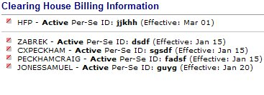
On the left side of the screen are listed the Active physicians/orgs and on the left side are the inactive physicians/orgs.
Add:
- Add/Edit button to Active physician/org side.
- Edit button to Inactive physician/org side.
- Names of physicians and Orgs.
- Add End date on the Inactive side.

Edit:
- List Orgs in alphabetical order by name.
- List Names in alphabetical order by last name.
Adding new physician or Org to Clearinghouse
User clicks Add button →application takes user to dialogue to add
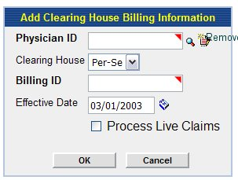

If user needs to look up ID of Physician, user clicks look up feature→application to user to search engine for physician→ Look up at Physician Name
This lookup, whether an icon (magnifying glass or the words are a hyperlink) should take user to a search dialogue which allows the user to search for a person—see below. ***Note the method chosen for lookup should stay consistent throughout the application. **

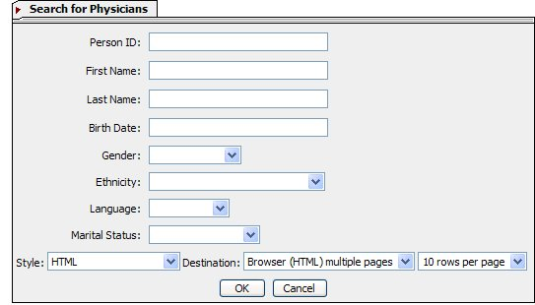

This is a good search engine, because it is a search engine for all persons.

Add

- If birth date has to be in a certain format, then to the left of the Birth date box, should be a message stating the format (mmddyyyy). **Note: Anywhere in the application, where information should be entered in a certain format, there should be a small example of it near the field.

Once the user clicks OK, the system should pull up the results. See below. ***Note: Search results include all types of persons.

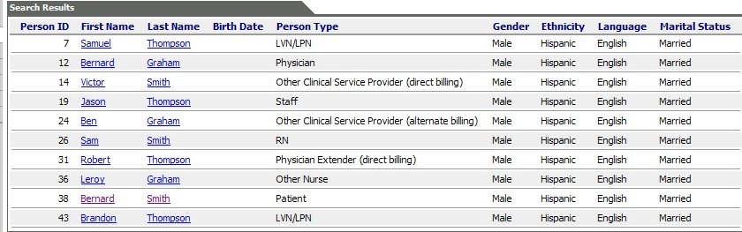

Edit

- The hyperlink to the patient summary should be on the person ID.
- Switch Last Name column with First Name Column
- Sort in alphabetical order by Last Name.
- The results should only consist of physicians; this does NOT include providers that are referring physicians only.
→User clicks Physician ID →application auto fills Physician ID in dialogue to add physician to a clearinghouse.→User completes dialogue and clicks [OK]→application takes user to a screen that confirms add
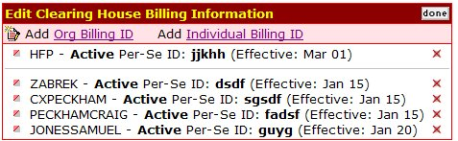

If user does not need to add anyone else, they click [done]→application takes user back to Clearing House main page.

If user needs to add another physician, they click Add→application goes to add dialogue again and continues loop until user clicks [done].

These same rules apply to Org Billing ID.

Editing an Org or Physician

User can edit an existing ID by clicking the to the left of the Physician Name or Org Name.→Application takes user to the edit dialogue
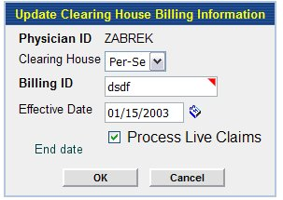
User makes necessary changes→clicks [OK]→Application shoes update→
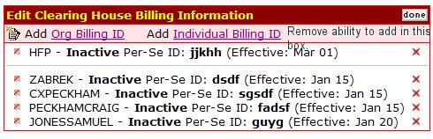
If user does not need to edit anyone else, they click [done]→application takes user back to Clearing House main page.

If user needs to edit another physician, they click →application goes to edit dialogue again and continues loop until user clicks [done].

These same rules apply to Org Billing ID.

Removing ID
A user should be able to make a Physician Inactive or an Org inactive. The user clicks the application takes user to update screen
User clears Process claims box and enters an end date→user clicks [OK]→application displays update by taking user to box that displays only inactive Physicians and Orgs.

Persons: Not a priority 5
This category gives a breakdown of persons within the Main Org. Currently, Physia handles this capability but it lists all persons under the Personnel Tab. This should be a view only tab and the user should not be able to add or edit from here. Here is an example of the field in Physia:
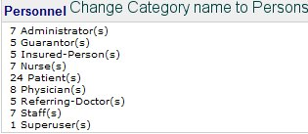

Personnel Tab: Priority 5 (only the password portion).

This tab contains information pertaining to employees and providers of the practice. The user should have the ability to add and edit personnel. They should also be able to assign or change passwords. If there are any inactive persons, there should be a separate category for them. Since this is not a priority 5, it will be discussed in a later document.

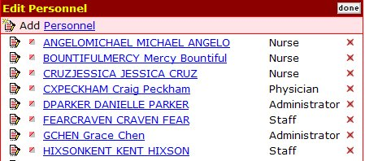

Add:
- Column for Last Name (before Person ID)
- Column for First Name (before Person ID)
Edit:
- Should allow user to change password
- Alphabetize by Last Name

Adding a Password
The user should be able to add a password for any of the above persons. This password allows the Person ID to log into the application.
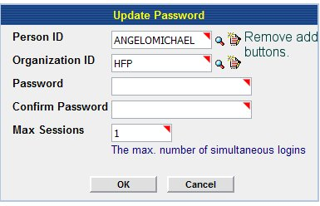
Remove:
- Add buttons from this screen.
- Look up buttons.
- Organization ID.

When the user clicks the in front of the Person, the application should take the user to the above dialogue→application auto fills Peron ID→User enters required information→user clicks [OK]→application stores password.→Application acknowledges change→application goes back to Personnel Tab.

Editing password.
The user should be able to change a password for any personnel. The screen should look similar to update password above. **This should only be available to super users and administrators.

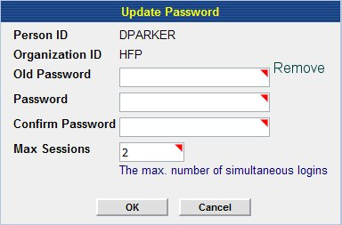

Add:
Field for super user password or administrator password and make this a required field.

Remove:
Requirement for Old password

The user enters information→clicks [OK]→application acknowledges change→Application goes back to Personnel Tab.

Editing Personnel information: Not a priority 5—see editing functions at Person Pages in a following document.

Deleting Personnel: Not a priority 5-details in a following document.
The user should have the ability to archive a person from personnel. Since a person can be in multiple categories, it is possible that a person can be archived from personnel but still be a patient or a referring physician. Because of this, a person archived from this category type should remain visible in the org. They should be listed in a separate Category on the Personnel Page. This Category should be labeled Inactive and function like the inactive key in Clearing House.

Catalog: Priority 5

This Tab holds information for Fee Schedules and Superbills and Contracts. The only items that are Priority 5 are the Fee Schedules and Superbills.

Fee Schedules
This should list all the Fee Schedules in the Main Org.
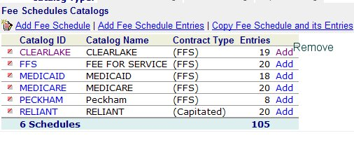
The user should be able to manage fee schedules from this screen.
Remove Add from the last column. It is redundant.

If the user clicks “Add Fee Schedule”, →application takes user to Add Fee Schedule Dialogue. (See document titled “Add Fee Schedule”.)**Note: When user saves new fee schedule—the application should take the user back to Fee Schedule Catalogs.

If user clicks “Add Fee Schedule Entries”, →application takes user to Add Fee Schedule entries dialogue. (See document titled “Add Fee Schedule Entry”) **Note: When user saves entries→the application takes user back to Fee Schedule Catalogs.

If user clicks “Copy Fee Schedule and its Entries”→application takes user to Copy Fee Schedule and its Entries Dialogue
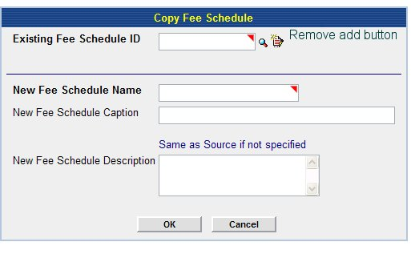
Remove Add button.
→User can enter fee schedule ID or look it up using hyperlink on words or icon (the look up should be consistent throughout the application)→
This look up takes user to a search engine for an existing Fee schedule. The user should be able to pull up using the following criteria:
Fee Schedule Name, Fee Schedule ID, Description, Physicians linked to Fee Schedule, Locations linked to Fee schedule
Fee Schedule Name
Fee Schedule ID | **User enters ID
Description
Associated Physicians | **User enters ID(s)
Associated Site Organizations | **User enters ID(s)

Once user clicks [OK]→application pulls up results:
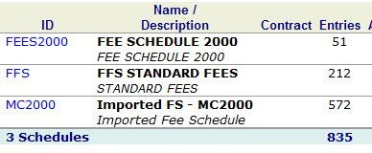
- User clicks look up→application takes user to search engine→user clicks Name/Description (Fee Schedule 2000)→application takes user to details of fee schedule
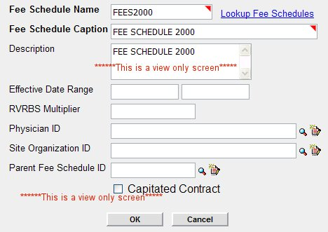

This is a view only screen. User closes screen→application takes user back to results→ if user sees the fee schedule for Copy, user clicks Fee Schedule ID→ Application pulls Fee Schedule ID into field for Fee Schedule ID.

Or
User clicks look up→application takes user to search engine→user does not see desired results and closes results window→application takes user back to Copy a Fee Schedule and its Entries dialogue.

If Fee Schedule is found and user picks it→User completes dialogue and saves→application acknowledges completion→application takes user back to Fee Schedule Catalog.

Edit a Fee Schedule:
Allows the user to edit the definition of the Fee Schedule. If the user clicks the to the left of the Fee Schedule→application takes user to Update Fee Schedule Dialogue
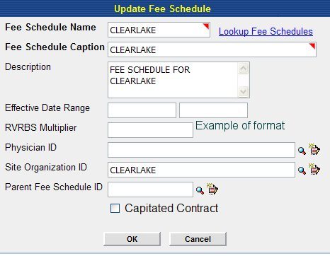
User makes necessary changes→clicks [OK]→application acknowledges changes are made→application takes user back to Fee Schedule Catalog.

If user clicks the Fee Schedule Name→application takes user to details of all items and /or entries for chosen Fee Schedule.
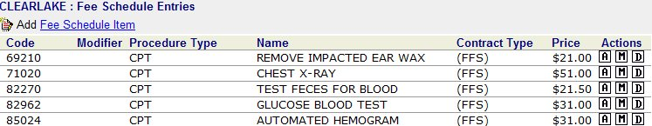

Here the user can update Modify entries, Add Fee Schedule Items or Delete Fees.
If the user clicks hyperlink for Add fee schedule item→application takes user to dialogue for Add a Fee Schedule Item. (See document titled “Add Fee Schedule Item) **once the user enters the information→the application should bring user back to above screen.

If the user clicks the Modify button→application takes user to Modify Dialogue
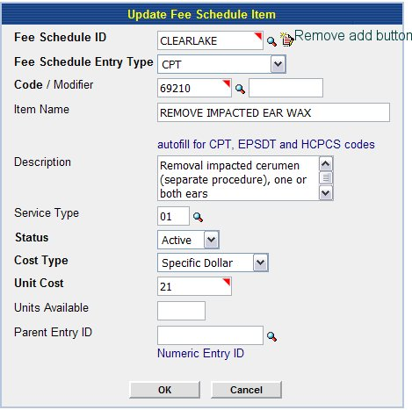
User makes edits. (The look up’s work the same as they do in Add a Fee Schedule item dialogue).→User clicks [OK]→application acknowledges changes → application takes user back to Fee Schedule Entries Screen.

If the user clicks the Delete button→application takes user to screen to delete fee schedule item
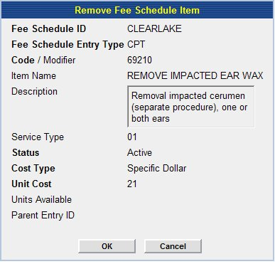
User clicks [OK]→application acknowledges deletion→application takes user back to Fee Schedule entries.

Account: Priority 5+30 Discussed in a later document.
Billing events are set up here. The user can manage them from this screen.

Associated Orgs: Discussed in Later Document

